Case 13-US-Kicking Bear Pipe

IA-[Wanampito](https://en.wikipedia.org/wiki/Iowa_archaeology" \o "Iowa archaeology) site Area (13BM16), Bremer Co.-Pipe-Rattlesnake-MN Pipestone Catlinite- and Spiral Maple Calumet-Ioway-17th c

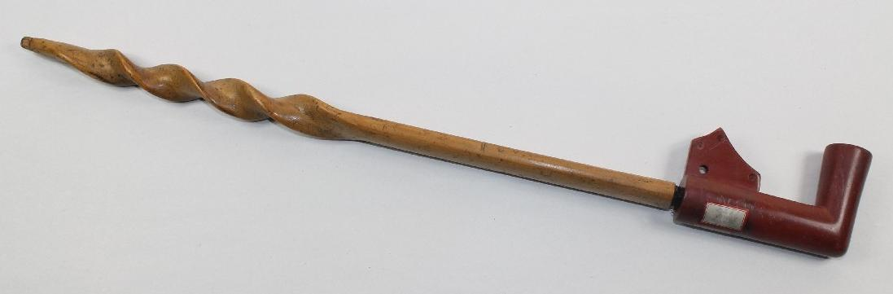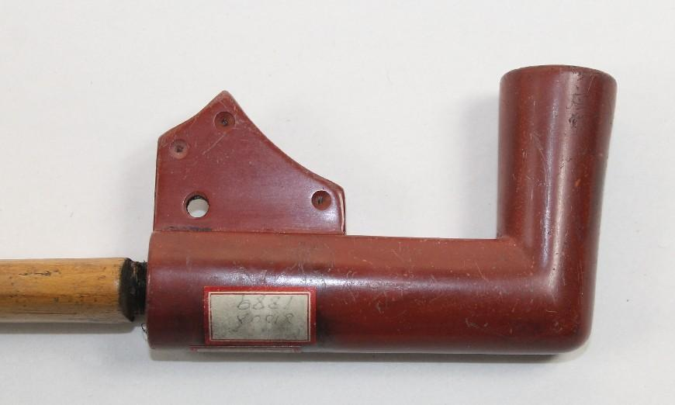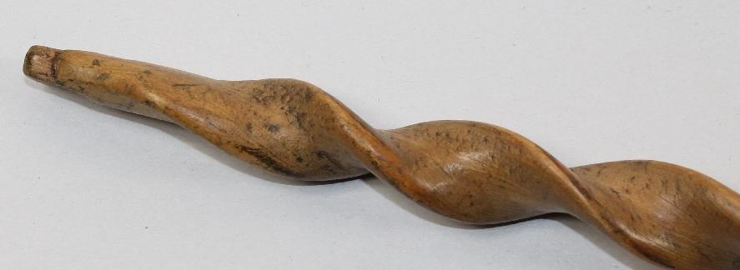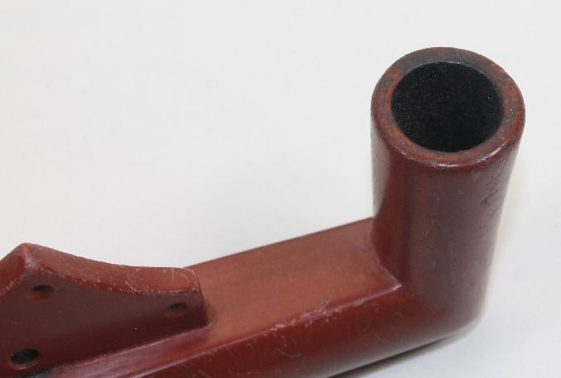

Figs. 1-4. US-IA-[Wanampito](https://en.wikipedia.org/wiki/Iowa_archaeology" \o "Iowa archaeology) site Area (13BM16), Bremer Co.-Pipe-Rattlesnake-MN Pipestone Catlinite-Spiral Maple Calumet-Ioway-17th c

|  |
| --- |
| Pipestone in the Upper Midwest is frequently associated with the so-called “calumet ceremony” (Blakeslee 1981; Brown 1989) that was coined from the Norman word “Chalumeau” or “hollow reed” named for the stem of the pipe, which was considered the most sacred part of the smoking apparatus. The two parts of the pipe consists of the stem which was affixed to a stone bowl, originally colored red which was considered to have the force of new life, since it was the color of blood. In some First Nations societies, the smoking of the pipestone pipe, usually in its red color variants began to have the force of re-vitalization, much like a blood infusion, and it is this life-force of the act of smoking this sacred instrument made of the female stem and the male bowl that sanctions a person to be reborn into new life circumstances (Brown 2007:95–96). Those smoking this holy instrument were experiencing what the early Christians called “meta-noia” or assuming a being of a “new spirit” or “turning over a new leaf” in their spiritual being. Henceforth, they were spiritually reborn into new fictive relationships with those participating, as the now joined pipe stem and bowl was passed right to left among those present, but not before the pipe, stem first was pointed to the four cardinal directions and to the Great Spirit above. This “calumet ceremony” likely began on the Great Plains and spread east onto the Prairie Peninsula and the Eastern Woodlands (Blakeslee 1981).  Therefore, this ceremony contains “an adoption ritual . . . which establish[es] a fictive kinship relationship between individuals of different clans, bands, or ethnic groups” (Blakeslee 1981:759), thus making “friends out of foes” (Brown 1989:313), a crucial element in establishing peace among those participating in seasonal Rendezvous in which goods or nubile youth are exchanged. Similar pipe bowls have been excavated in locales where seasonal gatherings occurred confirming this proto-historic ceremonial.  This sacred pipe stem and bowl once belonged to Kicking Bear, (March 18, 1846 – May 28, 1904), also called **Matȟó Wanáȟtaka**.  https://upload.wikimedia.org/wikipedia/commons/e/e4/Kickingbear.jpg  **Matȟó Wanáȟtaka**. After <https://upload.wikimedia.org/wikipedia/commons/e/e4/Kickingbear.jpg>  He was a “holy man” or “medicine man,” who was born as a Lakota within the Oglala sub-group but became a sub-chief and holy man among the Minneconjou another Lakota sub-group during the period known as the Sioux Wars (1854-1890), that began when he was eight–years-old and lasted throughout his life including the Ghost Dance period in which he took an active rôle as the Lakota were struggling to achieve proper political recognition in land treaties with the infant American Government.  Since both the Oglala and the Minneconjou belonged to the Lakota Nation of the Sioux, Kicking Bear was a first cousin and close friend of Chief Crazy Horse (Tashunka Witko) who was known as a farsighted chief, dedicated to the preservation Lakota traditions and moral principles. In battle, he was a great general who led his people to oppose the invasion of their homeland by the white man. As a fierce enemy and an expert equestrian, which is how he got his name, Crazy Horse proved to be a potent adversary on the battlefield against the U.S. Army and its Cavalry.  Crazy Horse  After  Kicking Bear married Woodpecker Woman, the daughter of Chief  Si Tanka, or Spotted Elk. Spotted Elk was the son of Lone Horn who in 1874 became leader of the Minneconjou — "Planters by the River" — subgroup of the Teton Lakota, one of the seven subdivisions of the Teton Sioux, who lived in northwestern South Dakota with the Hunkpapa, another band of the Teton Lakota led by Chief [Sitting Bull](https://www.u-s-history.com/pages/h3771.html).  Kicking Bear paid the marriage price with horses he had taken from the Siouan Crow Indians, who were continually at odds with the Ogala. By his marriage to a chief's daughter, Kicking Bear became a band chief in the Lakota Nation. Kicking Bear distinguished himself in several battles to fight for Lakota land during the War for the Black Hills (1876-77), including the Battle of the Little Big Horn.  In 1889, Kicking Bear traveled to Nevada to learn the new Ghost Dance religion, then brought it back to his After people. The Ghost Dance movement was revived (from an earlier form) in Nevada in the year 1888 by Wovoka, a Paiute Indian mystic and holy man. Performance of the dance was supposed to revive the native peoples' fortunes and traditions, rejoin them with their ancestors, and return their lands to a pristine state with buffalo and other wildlife in abundance. In addition, the white man would be swallowed up in the earth. The dance was performed by both men and women.  Upon Kicking Bear’s return, Chief Sitting Bull, Kicking Bear's uncle, asked him to demonstrate the dance at the Standing Rock Reservation in North Dakota, in October 1890. White officials became concerned about the ritual and dispatched police to escort Kicking Bear off the reservation. Nevertheless, Kicking Bear had taught the Ghost Dance to his people. Within two years, the dance would spread over most of the western half of the United States.  Just after Christmas in 1890, a shot rang out, and the U.S. Army effectively crippled the Ghost Dance movement among the Lakota when it slaughtered 290 men, women, and children of Chief Big Foot’s band, who were being held at a camp along Wounded Knee Creek. The Wounded Knee massacre was the worst domestic atrocity committed by the  U.S. Army in American history.  **U.S.** Government agents arrested Kicking Bear and imprisoned him in Fort Sheridan, Illinois. To alleviate tension and the possibility of renewed hostilities following the decline of the Ghost Dance, the U.S. government persuaded a group of prominent Sioux to tour with Buffalo Bill Cody's Wild West Show. In 1891, Kicking Bear’s sentence was commuted, provided that he join the show's European tour — an experience he would find humiliating. Following a year-long tour, Kicking Bear returned to the Pine Ridge Reservation in South Dakota, to care for that which mattered most, his family. Kicking Bear seemed to have just faded away after his return from the tour. He died on May 28, 1904, at the age of 51.  **Case no.: 11**  **Accession Number:**  **Formal Label:** US-IA-Bremer Co.-Pipe-Rattlesnake-MN Pipestone Catlinite- Ioway-17th c  **Display Description:**  **LC Classification:**  **Date or Time Horizon:**  **Geographical Area:**  **Map:**  **GPS coordinates:**  **Cultural Affiliation:**  **Medium:** The pipe is red catlinite from Pipestone Quarries in SW Minnesota. The pipe stem has one drill hole for suspension.  **Dimensions:** a matching pipe and stem. It measures 20" long overall. The Calumet stem is 16-1/2" long. It appears to be maple. The pipe is 4" long by 2-1/2" tall and well used and is 1-1/8" in thickness.  **Weight:**  **Condition:**  **Provenance:** There are a couple old labels on the pipe. They read, Kicking Bear, Sioux, 1889.  **Discussion:**  **References:** |

The **Iowa**/**Ioway** (English) or **Báxoǰe** [[b̥aꜜxodʒɛ]](https://en.wikipedia.org/wiki/Help:IPA), their autonym or name for themselves, which translates to "grey snow," (alternate spellings: *pahotcha*, *pahucha*,[[4]](https://en.wikipedia.org/wiki/Iowa_people#cite_note-ac-4)) are a ons [Siouan](https://en.wikipedia.org/wiki/Sioux) people. (Today, they are enrolled in either of two [federally recognized tribes](https://en.wikipedia.org/wiki/Federally_recognized_tribes), the [**Iowa Tribe of Oklahoma**](https://en.wikipedia.org/wiki/Iowa_Tribe_of_Oklahoma) and the [**Iowa Tribe of Kansas and Nebraska**](https://en.wikipedia.org/wiki/Iowa_Tribe_of_Kansas_and_Nebraska).) The word Ioway comes from Dakotan *ayuxbe* meaning “sleepy ones” via French *aiouez,* possibly from the Dakota having raided their camp when they were sleeping.[[3](https://en.wikipedia.org/wiki/Iowa_people#cite_note-koontz-3)

The Iowa, [Missouria](https://en.wikipedia.org/wiki/Missouria), and [Otoe tribes](https://en.wikipedia.org/wiki/Otoe_tribe) were all once part of the [Ho-Chunk people](https://en.wikipedia.org/wiki/Ho-Chunk_people) (or Winnebago people. They are all [Chiwere language](https://en.wikipedia.org/wiki/Chiwere_language)-speaking peoples. They left their ancestral homelands in Southern [Wisconsin](https://en.wikipedia.org/wiki/Wisconsin) for Eastern [Iowa](https://en.wikipedia.org/wiki/Iowa)

Appendix: Pipe with similar qualities from from the [Wanampito](https://en.wikipedia.org/wiki/Iowa_archaeology" \o "Iowa archaeology) site in [Iowa](https://en.wikipedia.org/wiki/Iowa)

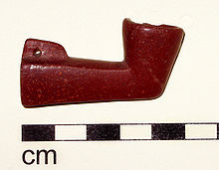

Protohistoric Catlinite pipe, probably late 17th century [Ioway](https://en.wikipedia.org/wiki/Ioway" \o "Ioway), from the [Wanampito](https://en.wikipedia.org/wiki/Iowa_archaeology" \o "Iowa archaeology) site in [Iowa](https://en.wikipedia.org/wiki/Iowa).